Reg.No.: 2116220701518

Practical 5

Aim:

Experiments on Packet capture tool: Wireshark Capturing Packets:

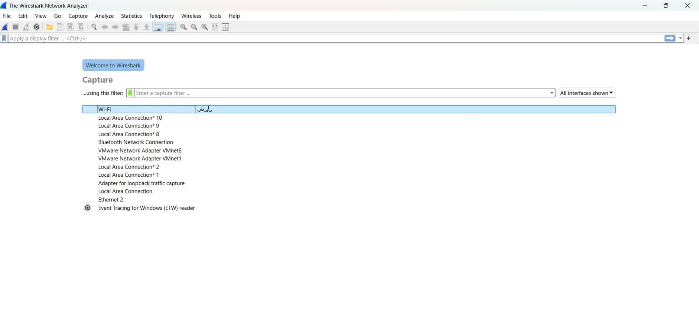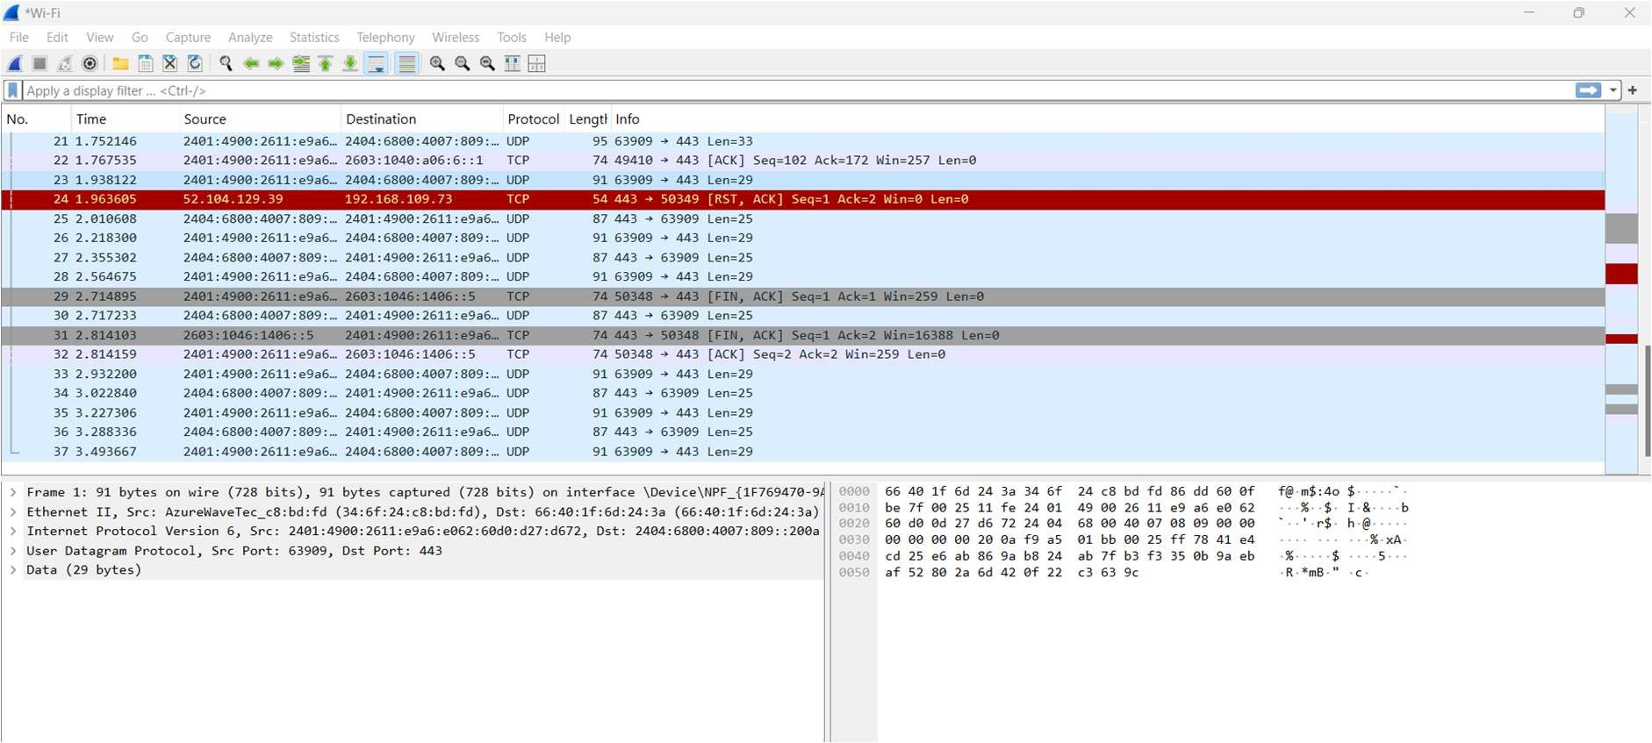

Color Coding:

Filtering Packets:

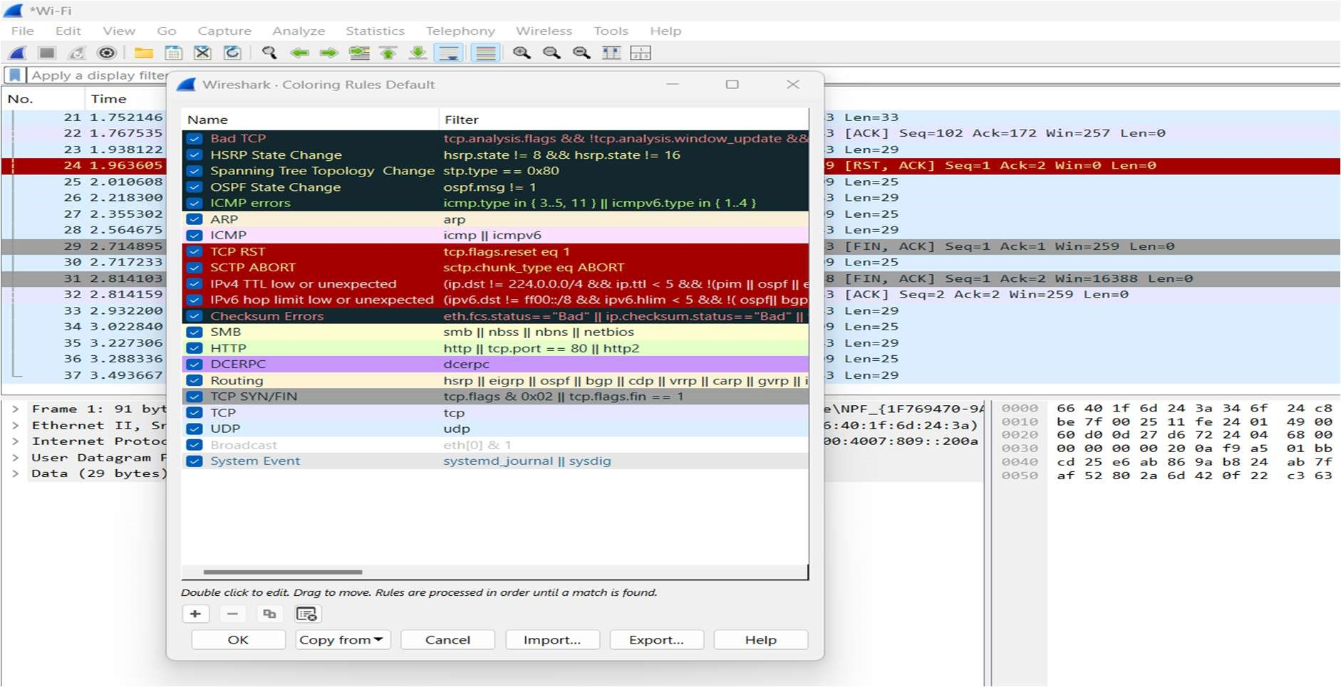

Display Filters:

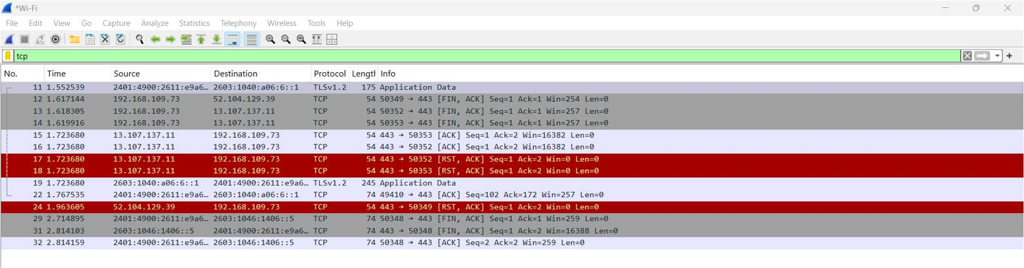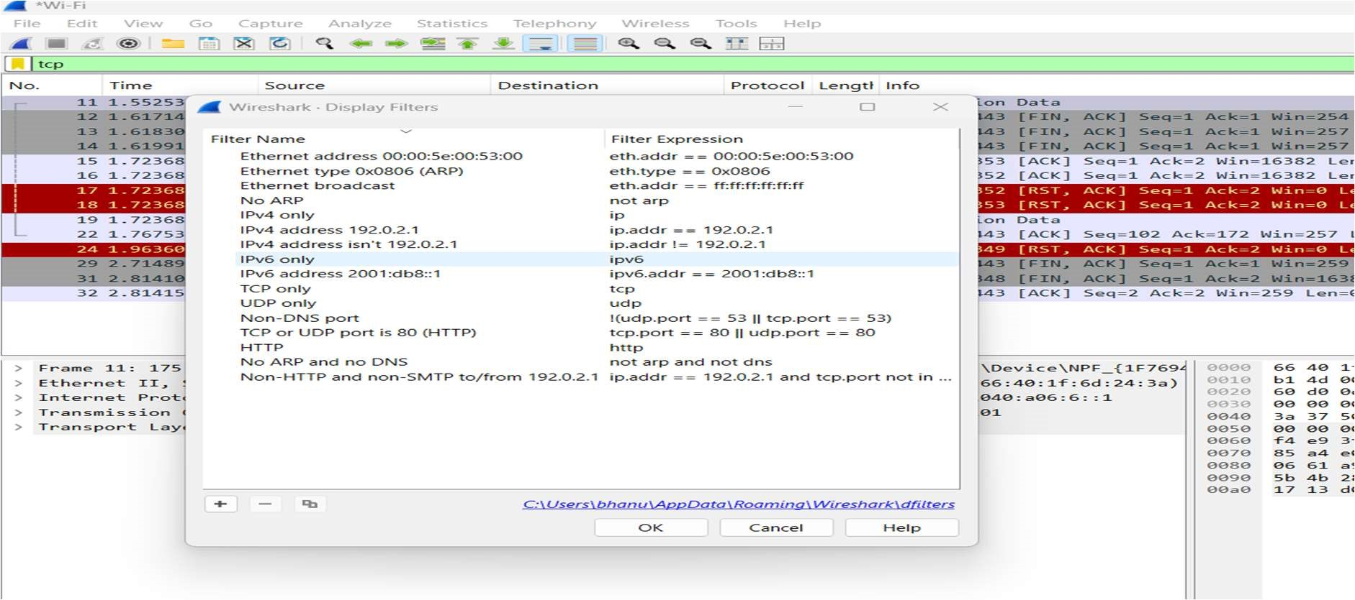

Tcp Stream:

Inspecting Packets:

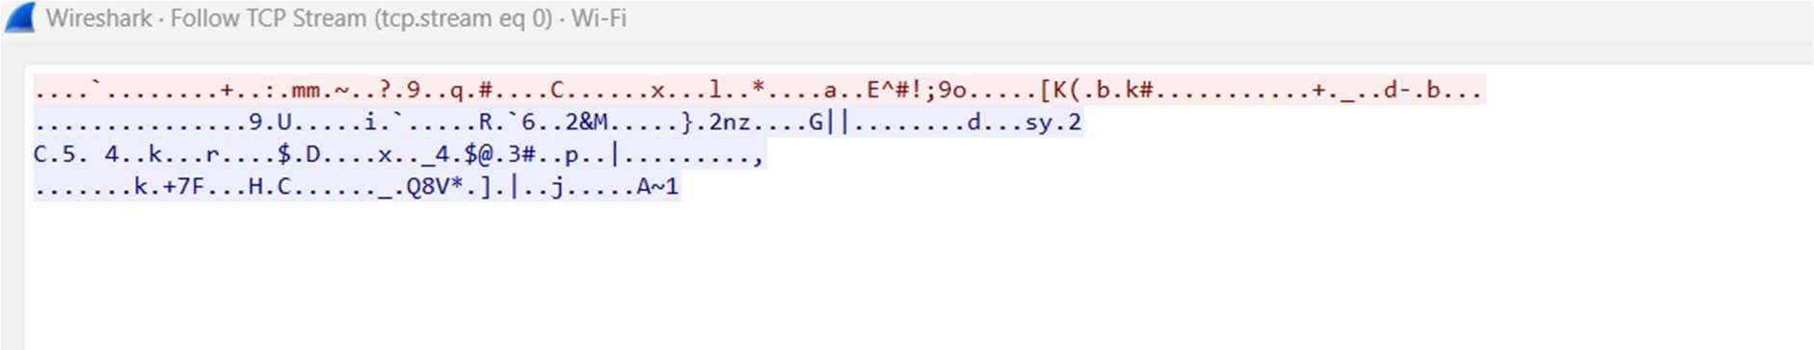

Flow Graph:

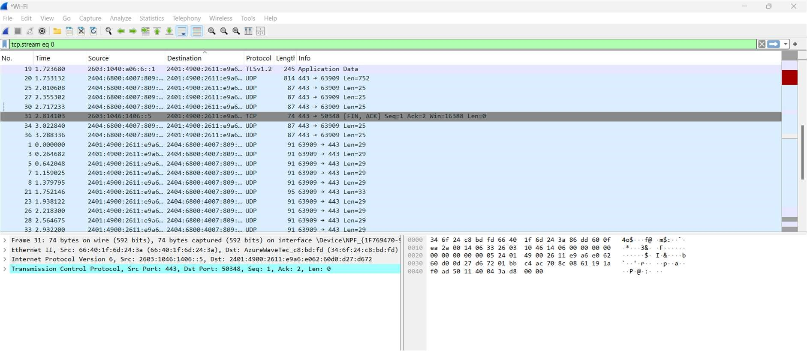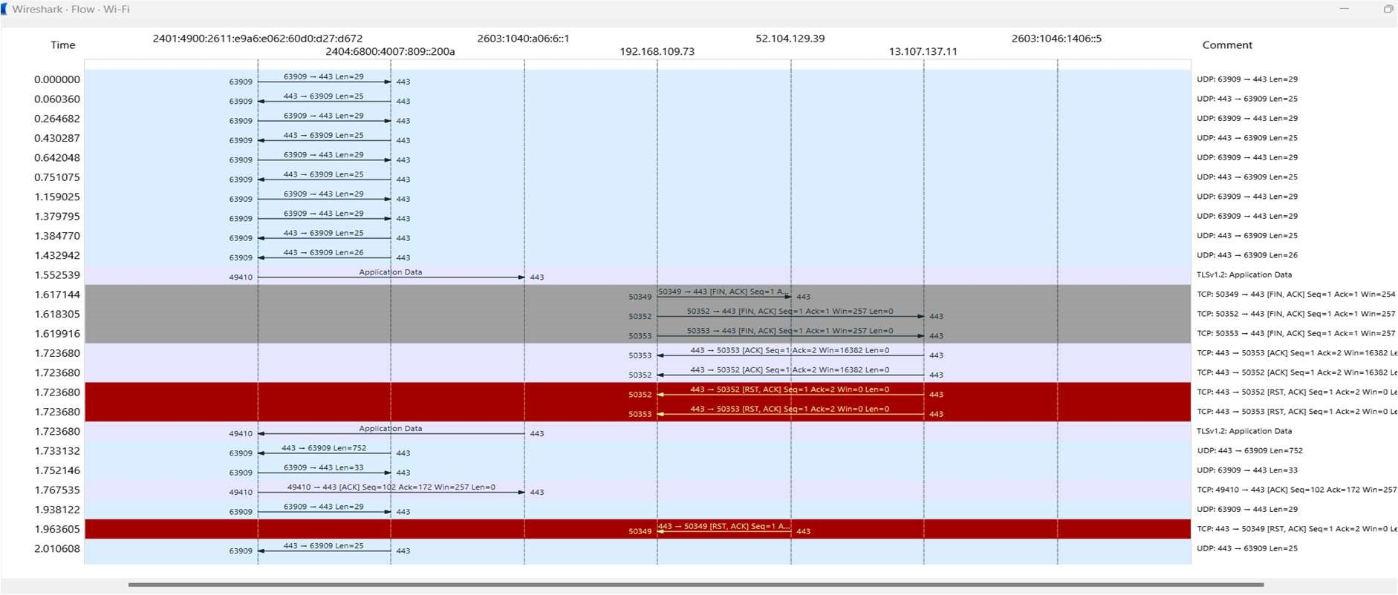

1. Create a Filter to display only TCP/UDP packets, inspect the packets and provide the flow graph

Procedure

Select Local Area Connection in Wireshark.

Go to capture →option

Select stop capture automatically after 100 packets.

Then click Start capture.

Search TCP packets in search bar.

To see flow graph click Statistics→Flow graph.

Save the packets.

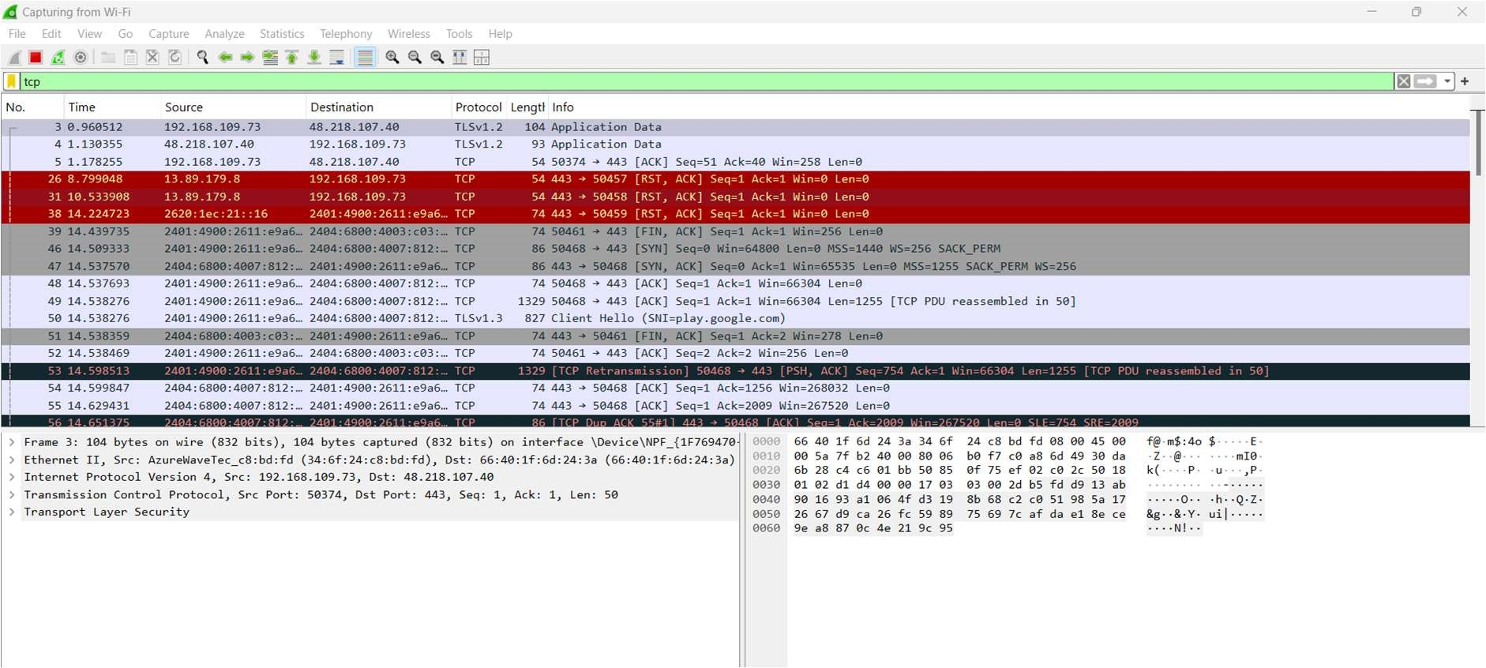

Flowgraph:

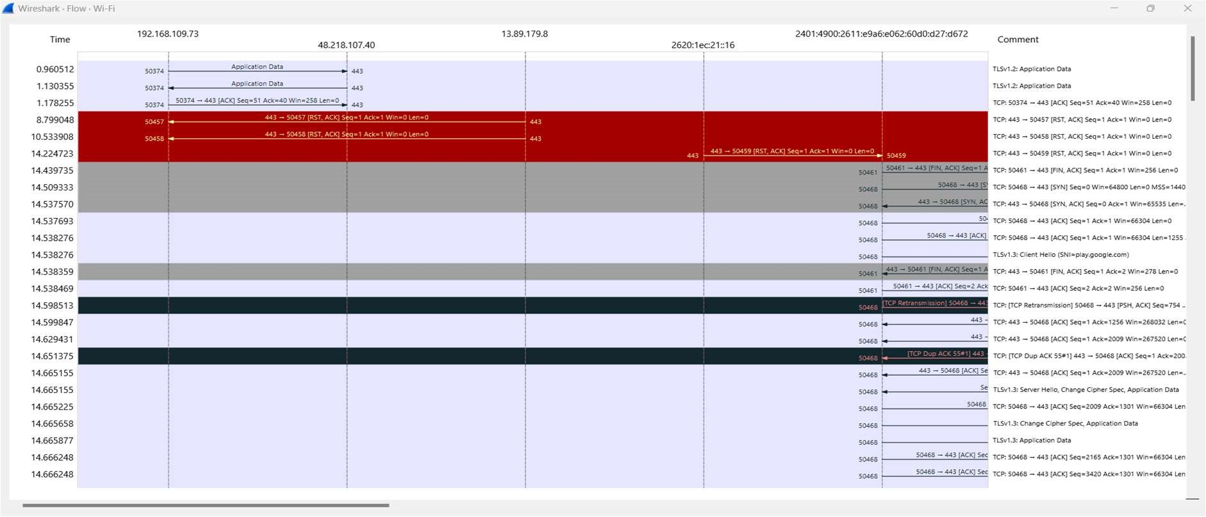

1. Create a Filter to display only ARP packets and inspect the packets.

Procedure

Go to capture →option

Select stop capture automatically after 100 packets.

Then click Start capture.

Search ARP packets in search bar.

Save the packets.

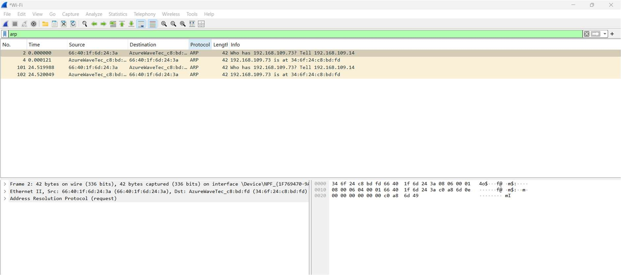

1. Create a Filter to display only DNS packets and provide the flow graph.

Procedure

Go to capture→option

Select stop capture automatically after 100 packets.

Then click Start capture.

Search DNS packets in search bar.

To see flow graph click Statistics→Flow graph.

Save the packets.

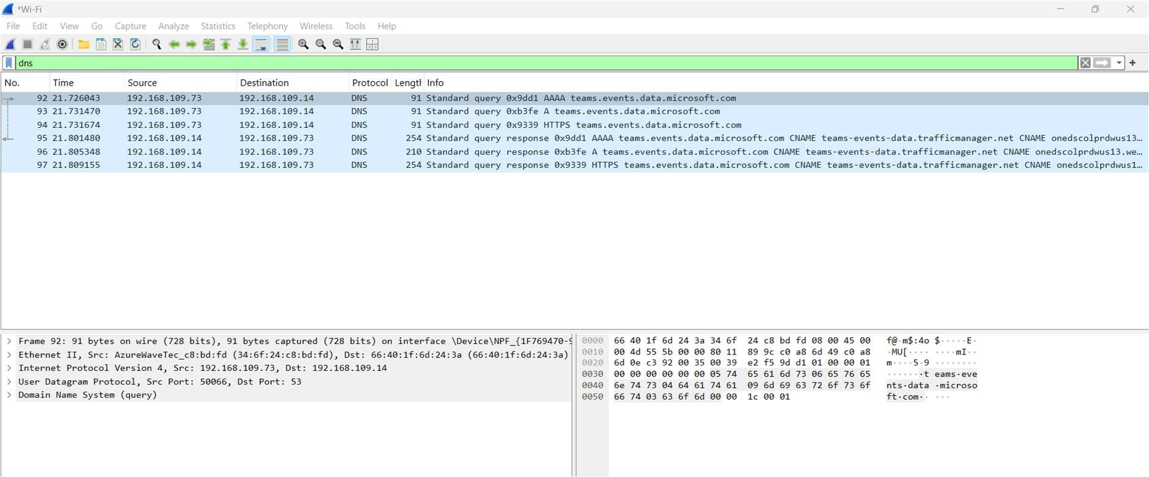

Flowgraph:

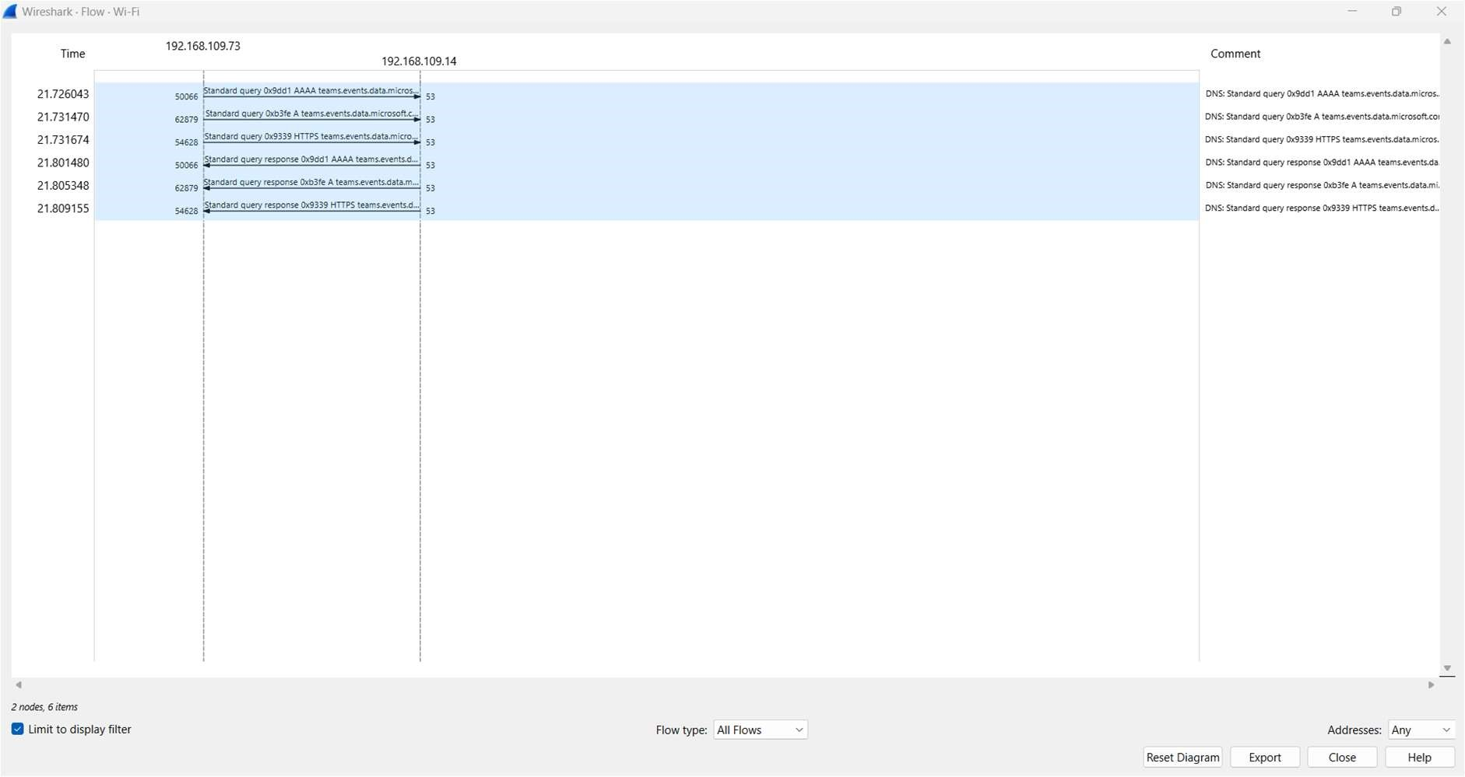

1. Create a Filter to display only DHCP packets and inspect the packets.

Procedure

Select Local Area Connection in Wireshark.

Go to capture →option

Select stop capture automatically after 100 packets.

Then click Start capture.

Search DHCP packets in search bar.

Save the packets

